**Technocrats**

Cody Walters

Jeremiah Greely

Brianna Prichard

Curtis Freudigmann

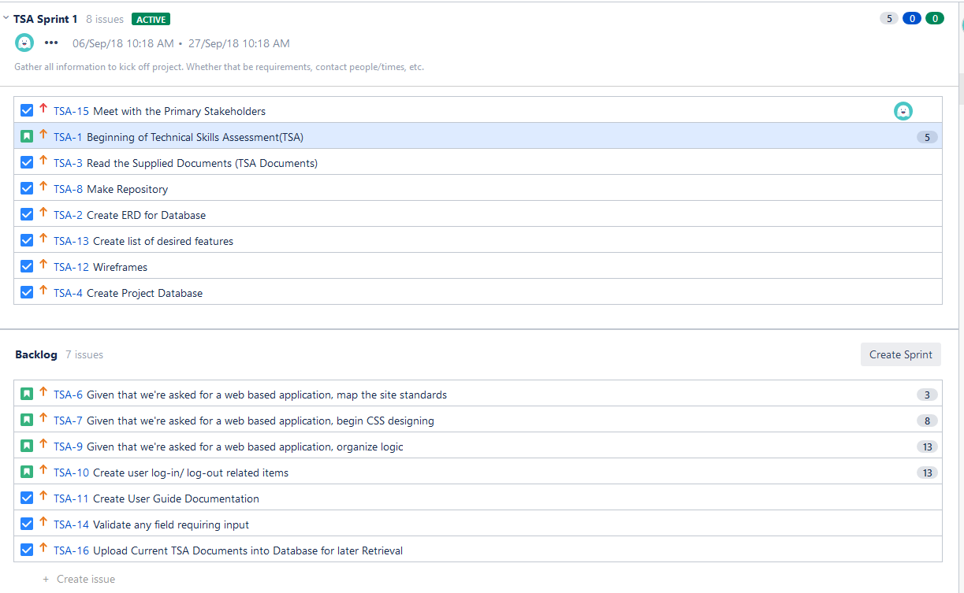

Our first Sprint was started before we were able to get a screenshot of the backlog. However, we did assign points to our next backlog to represent how it would look.

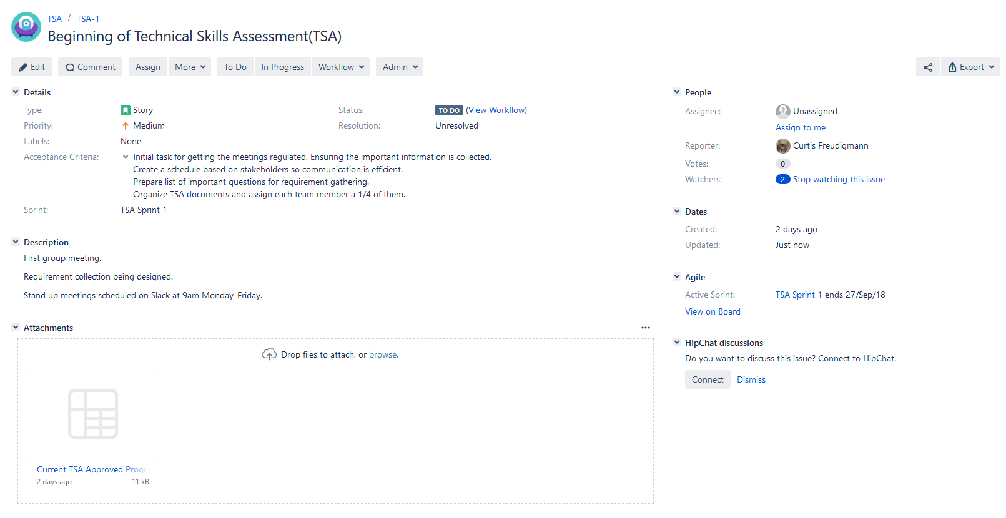

Before Sprint 1 started we had one User Story and six Tasks for a total of 5 story points.

To show how we would have done Sprint 1’s backlog we went ahead and prepared Sprint 2’s backlog also. This backlog has four User Stories and three Tasks for 37 story points.

This is the first sprint so we have not completed and story points yet.